# Installation of Keil Microcontroller Development Kit (MDK)

# & Project Creation

Jingtong Hu

January 8, 2019

## Section 1: Installation of Keil

**Warning: Do not connect the Discovery Kit into your PC or laptop before the software installation completes.** If you connect your kit to PC before installing the USB driver, Windows OS often mistakenly associates a wrong USB driver to the kit. Thus, you will not be able to program the kit. The solution is to go to the control panel and change the USB driver to ST-Link USB driver.

## Step 1: Install Keil MDK-ARM

* 1. Download the latest free evaluation version Keil MDK-ARM from the following link:

<https://www.keil.com/demo/eval/arm.htm>.

* Keil MDK-ARM contains µVision 5 IDE (Integrated Development Environment) with debugger, flash programmer and the ARM compiler toolchain.
* The major limitation of the free version is that programs that generate more than 32 Kbytes of code and data will not compile, assemble, or link.
  1. Run the downloaded MDK5xx.exe and install to the default path. The software takes 2GB disk storage space. You can install it to a different driver, instead of the default C drive, if there is limited space in C drive.

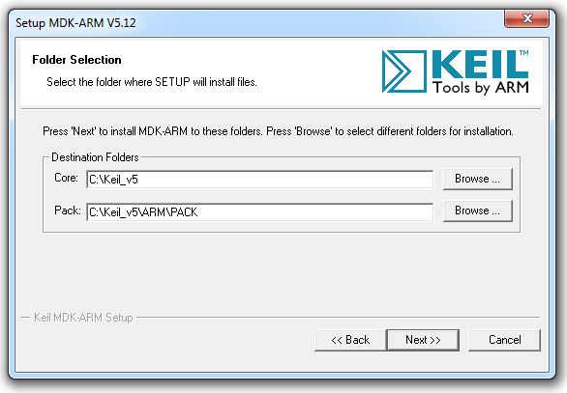

After the core software is installed, a dialog will show up to install Keil Pack. It automatically downloads selected components (called packs) from <http://www.keil.com/dd2/pack/>

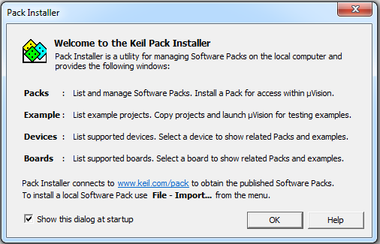

Click OK and then the following window shows up.

Select the device **STM32L4 Series**, install **STM32L4xx_DFP**.

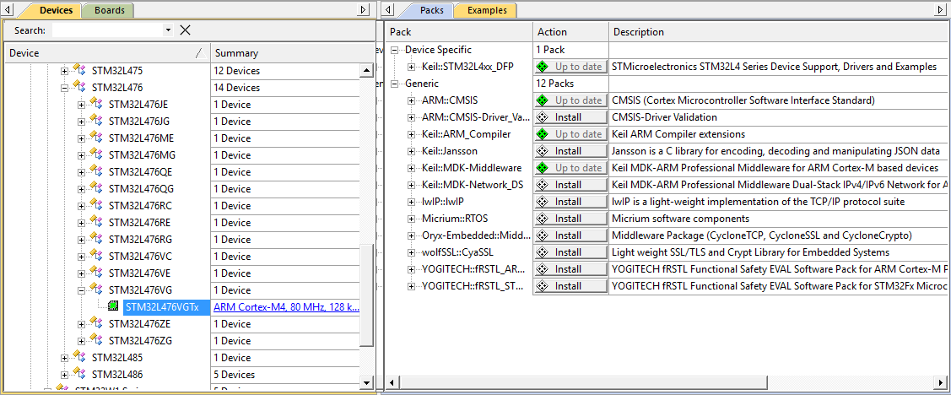

## Step 2: Install ST-Link USB Driver

* Do not connect the discovery kit before you install the USB driver for ST-Link.
* Go to the directory **C:\Keil_v5\ARM\STLink\USBDriver** and run **stlink_winusb_install.bat** in administrator mode.
* Now you can connect the discovery kit to computer via a "Type A to mini-B" USB cable. The discovery kit should be correctly recognized as “STMicroelectronics STLink dongle.”

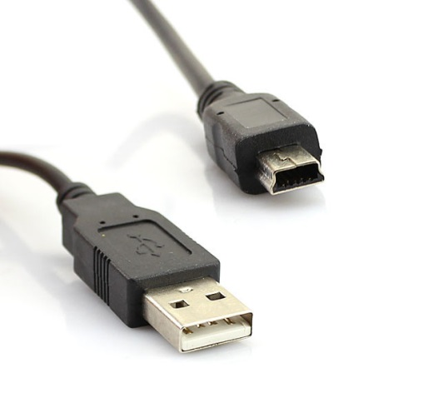

## Section 2: Project Creation

## Summary

This tutorial takes the following the kit as an example of creating a project in Keil IDE for assembly programs.

* Discovery kit with STM32L476VG MCU (Cortex-M4 with FPU and DSP)

Note that the project does not use the default startup files provided by Keil. You need to download a modified version of ***startup_stm32l476xx.s*** from Courseweb.

## Identifying Target Processor

|  |  |  |  |  |
| --- | --- | --- | --- | --- |
| **Kit** | **Processor** | **Core** | **Flash** | **RAM** |
| **STM32L4 Discovery Kit** | **STM32L476VG** | **Cortex-M4 (DSP + FPU)** | **1 MB** | **128 KB** |

## Steps to create a new project in Keil

1. From the menu **Project** ⟶ **New µVision Project**
2. Give the project a name and select its storage directory. In this tutorial, the project is named as “lab”.
3. Select the device **STM32L4 Series**, and then select **STM32L4476VGTx**.

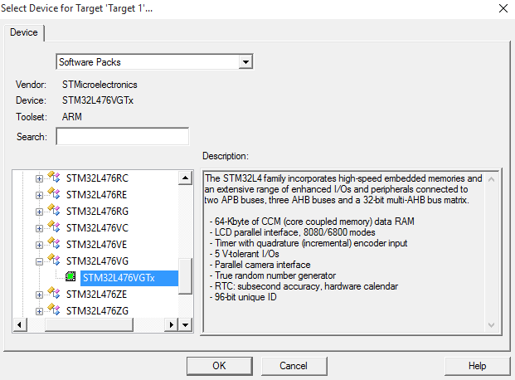

If did not see the targeted processor in the list, click the “**Pack Installer**” button and install the component **Keil::STM32L4xx_DFP**.

1. Select **CMSIS Core** only. Do NOT select “Device Startup”. Instead, you should use the one provided by the course website.

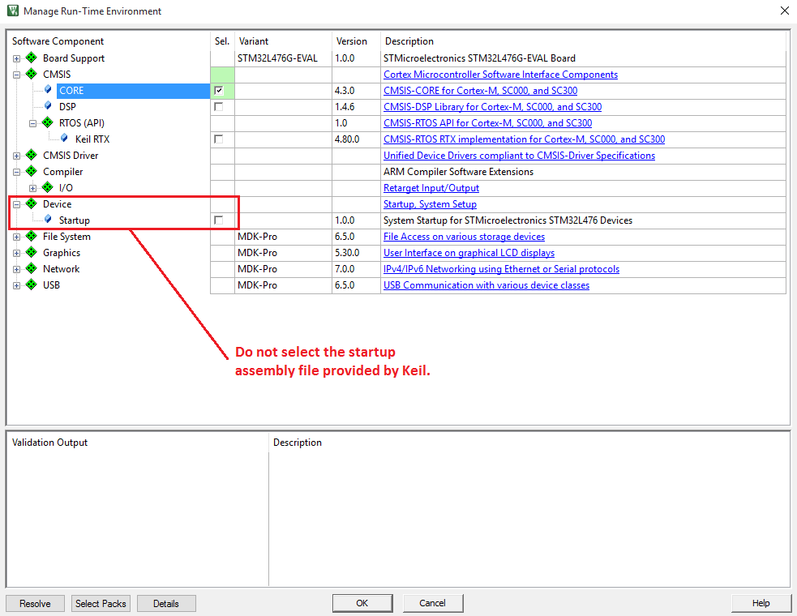

1. To create a project, you should download all the following files from Courseweb and include them in the project:

* **startup_stm32l476xx.s**
* **main.s**
* stm32l476xx.h
* core_cm4_constrants.s
* stm32l476xx_constants.s
* LCD.c

Note that LCD.h is not added to the project, but this file must be in the project folder because it is used by LCD.c

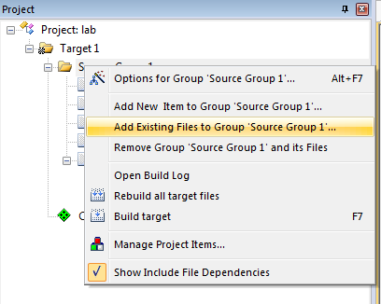

1. **Set Project Properties**

From the menu, click **Project** ⟶ **Option for Target**, Go to the **Output** page, select “**Create HEX file**”

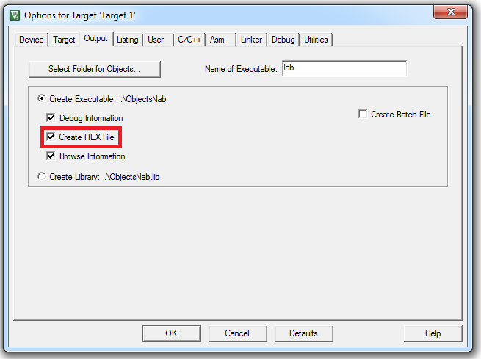

Go to the **Linker** page, select “**Use Memory Layout from Target Dialog**”

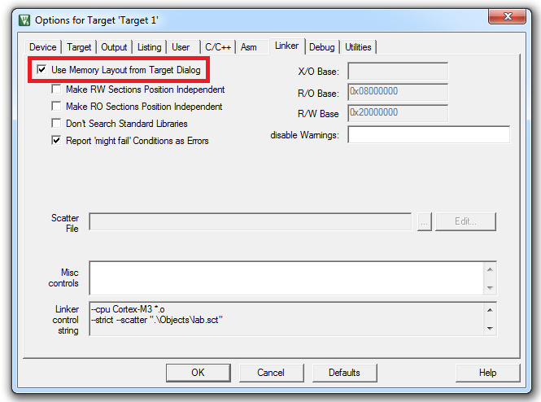

Go to the **Debug** page, select “**ST-Link Debugger”**

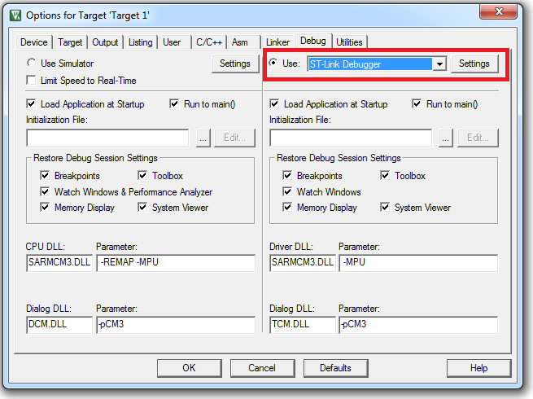

Click “**Settings**” and select “**SW**” (Serial Wire) as the port.

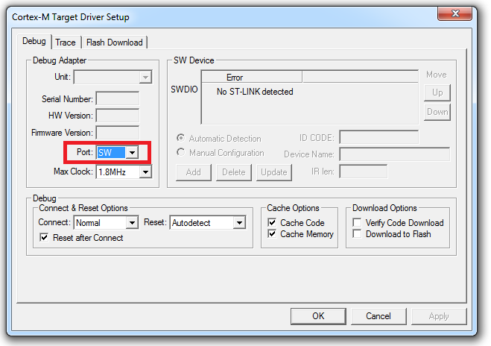

Go to the **Flash Download** page, and verity that **STM32L4xx On-chip Flash** is selected in the Programming Algorithm. If not, click “Add” and select STM32L4xx On-chip flash in the popped dialog.

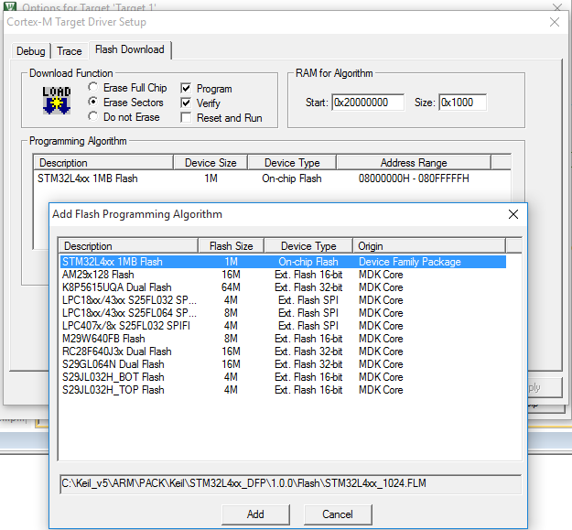

1. **Compile and run your project**

Build the program:

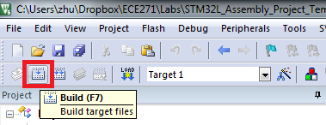

You can ignore the following warning when the linking stage:

.\Objects\lab.sct(8): warning: **L6314W: No section matches pattern *(InRoot$$Sections)**.

Connect your discovery kit to the computer and download the program to the STM32L processor.

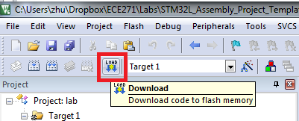

Push the Reset button on the board, and your program will start. By default, ECE177 will be displayed on the LCD.

**Please replace the "ECE1770" in main.s with your last name, compile and download again. Your last name will be displayed on the LCD.**